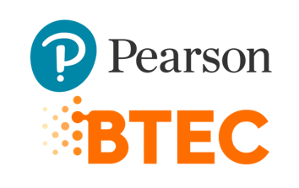



PROGRAM TITLE: BTEC IN COMPUTING (SOFTWARE ENGINEERING)

UNIT TITLE: WEBSITE DESIGN AND DEVELOPMENT

ASSIGNMENT NUMBER: 1

ASSIGNMENT NAME: WEBSITE DESIGN AND DEVELOPMENT

SUBMISSION DATE: 31/12/2022

DATE RECEIVED: 31/12/2022

TUTORIAL LECTURER: NGUYEN VAN HUY

WORD COUNT

STUDENT NAME: TO LAN THANH

STUDENT ID: BKC13127

MOBILE NUMBER: 0352039448

|  |
| --- |
| **Summative Feedback:**  **Internal verification:** |

**INDEX**

1. **Theoretical Basis.**
   1. **Domain and DNS.**
   2. **Web Server – Server.**
   3. **Frontend and Backend.**
   4. **UX/UI and tools.**
   5. **Software Testing and Quality Assurance.**
   6. **Technology and Frameworks used to develop the Website.**
   7. **SEO Website.**
2. **Website Design and Build.**
   1. **Problem Statement.**
   2. **Problem Analysis.**
   3. **Design Website.**
3. **Reference Links.**
4. **Theoretical Basis.**
   1. **Domain and DNS.**

* A domain is the location of a website. The term domain can refer to how the Internet is structured and how an organization’s network resoures are organized. The domain is labeled by its domain name, such as google.com.
* The Domain Name System (DNS) is the phonebook of the Internet. Users access information online through domain names, like google.com or youtube.com. Because browsers interact through Internet Protocol Addresses (IP), DNS translates domain names to IP Addresses so they can load Internet resources.
* Domain names are organized through subdomains which are the subordinate level of the root domain of the Domain Name System. A Top-Level Domain (TLD) is a collection of First-Level Domains and includes generic Top-Level Domains (gTLDs) such as .com and .org as well as the country code Top-Level Domain (ccTLD).
  1. **Web Server – Server.**
* Web Server is the server used to handle the access sent from the client through the HTTP Protocol. Web Server can be software of hardware or both work together.
* In terms of hardware, Web Server is a computer that stores the component files that make up a Website (such as HTML, images, CSS, JavaScript, etc.) and transmits it to the end-user. The Web Server is connected to the Internet and accessed through a domain.
* In term of software, Web Server includes some parts that control web users’ access to the hosts file at HTTP Server. An HTTP Server is a market share of software, known as URLs (Web Addresses) and HTTP (the protocol browsers use to view web pages).
* Client Server is a computer network model consisting of two main components: The Clients (Client) and The Server (Server). The Server is a place to help store resources as well as install service programs according to the client’s requirements. In contrast, The Client includes computers as well as general devices that will send requests to the server. The Client – Server network model will allow a centralized network of applications with the same function at one or more dedicated file services. They will become the center of the system.
* Protocols for accessing the web server:
* HTTP Protocol: Web browsers communicate with web server to retrieve web pages through the use of hypertext transfer protocol (HTTP). It is a TCP/IP based communication protocol used to deliver data over the World Wide Web. It provides standards for computers to communicate with each other. HTTP defines how the request client should construct and send data to the server, and how the server responds to these requests.
* HTTPS Protocol: HTTPS (Hypertext Transfer Protocol Secure) is a secure Hypertext Transfer Protocol. In essence, this is the HTTP Protocol but integrates an SSL Security Certificate to encrypt communication messages to increase security. Understandably, HTTPS is a more secure version of HTTP.
* FTP Protocol: FPT (File Transfer Protocol) is a communication protocol commonly used to exchange files over a communication network located in the application layer of the TCP/IP protocol suite. FTP requires at least two computers, a server called FTP Server and an FTP Client machine to work.
* Steps to publish a Website to the Internet:

1. Pick a Web Hosting Company.

* It's important to understand that building and maintaining a website is a serious undertaking. Selecting a top-notch web host with all the necessary features to launch your project is essential.

1. Choose Website upload method.

* Choosing the best tool to upload your website to the internet presents the next challenge. Here are four of the most popular tools to upload a website:

+ File Manager: A file manager is a browser-based tool with all the essential capabilities for managing the files and directories on your website. However, the File Manager has an upload limit. If your website files are larger than 256MB, you should opt for the next tool instead.

+ File Transfer Protocol (FTP): You can connect to an FTP client by using the file transfer protocol, which is supported by the majority of web hosting companies. Install an FTP client on your computer if you don't already have one. Using an FTP program to upload files has no size restriction. However, it does take a bit of technical knowledge on how to configure FileZilla and any other FTP clients.

+ Wordpress Migration Plugins: There are several ways to upload your website to the CMS if you intend to use WordPress. Using a WordPress migration plugin like All in One WP Migration is one of the simplest methods. The remaining actions are self-explanatory after the plugin has been installed and activated.

1. Upload files to your website.
   1. **Frontend and Backend.**

* Frontend is the part of a website where users can interact to use, everything you see on a website including: fonts, colors, product categories, menus, sliders, etc are the perfect combination of HTML, CSS and Javascript.
* Popular Frontend technologies:
* React: React is an open source frontend JavaScript library used to create interactive user interfaces (User Interfaces), which improves the speed of applications. It is one of the simplest frameworks to learn and was developed by Facebook to solve code maintainability issues caused by continuous additions and improvements. Facebook and other front-end engineers still maintain it.
* Angular: Angular is an open source, modern TypeScript-based framework and one of the most highly regarded software development tools. The Angular Directives feature allows developers to program special DOM behaviors that help create rich and dynamic HTML content. Angular has hierarchical dependency injection functionality, makes code components easier to test, reuse and control: it helps to define code dependencies as externals that separate components from their dependencies.
* Vuejs: Vue is one of the most beginner-friendly frameworks, comes with well-written documentation and a supportive community. Vue has a wide selection of tools, such as a terminal testing tool, a plugin installation system, a browser debugger, a server renderer, a state manager, and others. Vue has a virtual DOM, component-based architecture, and two-way binding that underpin its high-speed performance: all of which makes it easy to update related components and track data changes.
* jQuery: jQuery was one of the earliest frontend frameworks. jQuery provides simplicity and ease of use, while minimizing the need to write extensive JavaScript code. jQuery is used to manipulate the CSS and DOM and optimize the functionality and interactivity of a web page. It allows developers to build native mobile apps with an HTML5-based user interface system – jQuery Mobile. jQuery is browser-friendly and supports whatever browser you plan to use.
* Emberjs: Emberjs is component-based and provides two-way data binding similar to Angular. It is designed to meet the increasing demands of modern technology seamlessly. It is used to develop complex web and mobile applications with Emberjs and hopefully its efficient architecture to handle concerns.
* Backend is all the parts that support the operation of the website or application that cannot be seen by the user. Arguably Backend is like the human brain. It processes requests, commands, and selects the correct information to display on the screen. The Backend of any website is made up of three components: the server, the application, and the database. Thanks to it, the website works effectively, providing accurate information with fast speed to users.
* Popular Backend technologies:
* Java: It's hard to talk about languages ​​to learn when learning backend programming without mentioning Java. Oracle created this multi-purpose, cross-platform, object-oriented, and concurrency programming language. Most backend software developers prefer Java because it allows them to convert (compile) code into Java bytecode, which can then be run on the Java Virtual Machine (JVM). Therefore, programs developed in Java can run on any device where the JVM can be installed.
* PHP: PHP is ranked second in the list of popular backend languages ​​(Hypertext Preprocessor). PHP is one of the languages ​​suitable for beginners to learn Backend programming because of its characteristics such as cross-platform, flexibility, dynamic and open source.
* .NET: ASP.NET is an online application framework from Microsoft for developing web applications and services using Visual Basic (VB), C#, F#, and other languages. The Model-View-Controller (MVC) model in .NET supports backend operations by allowing a controller to communicate with a model to process data. The results will then be displayed as a UI page on the view. Many organizations consider .NET to be the best choice because of its stability and reliability, as well as Microsoft's support.
* Python: The Python programming language is closely associated with the seven most popular back-end languages. Python is currently one of the most popular and rapidly growing backend languages ​​in the world. Python is a great choice for beginners because of its simple syntax, easy to understand, and many online courses. Python is also used in machine learning, data science-based online application development, GUI design, and prototyping. On the other hand, Python is not recommended for mobile computing.
* Ruby: Ruby is a dynamic, cross-platform, object-oriented, and reflective programming language that is freely available. This language is one of the best alternatives for developing prototypes and is often used for simple tasks like creating blogs. Ruby can also be used to create online apps, games and mobile apps, as well as automating monotonous operations. Ruby aims to reduce the uncertainty associated with programming by adhering to the concept of least surprise, aka POLA (Principle of Least Surprise).
* SQL Query Language: In the field of back-end programming, SQL is another prominent programming language (Structured Query Language). SQL is a query language that allows you to communicate with databases. SQL is also the best choice for those who are just starting out with backend programming. SQL is a declarative language, which means that programmers can express the results they want to achieve after running the code without having to specify stages or processes in detail. All in all, learning how to use SQL is a must if you want to get the most out of databases or learn about Big Data.
* JavaScript: Because their names are so similar, many people have mixed up the two programming languages ​​Javascript and Java (JS). So when studying the backend, keep in mind that JavaScript is completely different from Java and has nothing to do with Java. Because it is a dynamic, untyped, and interpretable high-level language, JS is extremely popular in the back-end industry. Also, when compared to other back-end languages, JS has the advantage of being able to generate and run code directly in a web browser. When it comes to building dynamic websites, it's fair to say JS is an important component of the "famous trio", hence the Backend should be fluent in this programming language.
* Differences between Frontend and Backend:
* A concept that contrasts with BackEnd is FrontEnd. If BackEnd is the sink, then FrontEnd is the tip of the iceberg. More specifically, FrontEnd is the part that displays outside the interface and interacts with the user. So it focuses on visuals, aesthetics, and easy-to-use layouts. And BackEnd is the work related to the internal database to display to the server. The main function is to store data, retrieve information quickly and accurately with each command given.
  1. **UX/UI and tools.**
* Principles in UX/UI design you should know:
* Understanding user psychology.

+ Learning and understanding the user’s psychology is a basic and important requirement that need special attention. Determining the user’s psychology helps us to have the right direction and plan to write the appropriate web and to create the most perfect product. Know what customers really want, looking forward to something new helps the final decision to be made is the most appropriate and accurate. This is extremely important because it ensures the perfect final product.

* Focus on minimizing information content:

+ Normally, users will spend quite a short time, only a few second to consider and decide whether to click on that website to learn more details and thoroughly. Therefore, building the first impression, creating attraction is extremely important and necessary. Minimizing the content to the maximum extent to make the web easy to understand and friendly for all users is extremely important and necessary. Through that, it can help readers to understand thoroughly and in detail as easily as required. Simple but complete content, provide the necessary information to help us attract some customers to visit the website more effectively.

* Prefer to use interactive icons:

+ When designing UX/UI for any website, the user orientation is at the heart of all activities. Therefore, the principle when completing the web is to pay attention to prioritize the use of interactive icons for your website. Showing interaction is essential because it helps users not feel left out, ignored and actions they take do not seem to receive a response. The calculation to prioritize the appropriate icon helps each customer get a better experience, avoiding the feeling of boredom when accessing the website for their own needs and purposes.

* Main focus on features:

+ To design standard UX/UI web, focus on features is a principle, an important standard that needs to be ensured. In addition to the aesthetic factor that needs to be balanced, focus on developing all the necessary new features to bring about high efficiency as required. Having a website with all the necessary features will definitely further enhance the user experience. All practical requirements are now well met, effectively resolved as desired. Thereby using the web is likely to promote the advantage at the highest level.

* Content when designing needs to be consistents:

+ Website standard UX/UI or not is simply evaluated based on the interface and features, but the content is also very important and should be fully considered. Through that, it is possible to provide customers with the most valuable and useful information. Create consistent content, following a system is an important principle in UX/UI design that every programmer should pay great attention to.

* Popular UX/UI tools:
* Adobe XD:

+ Adobe XD, aslo known as Adobe Experience Design CC, is a graphic software that includes many useful features to help create and share a variety of UX/UI designs for mobile apps and websites.

* Figma:

+ Figma is a web-based graphic editing and UX design aoftware. You can use it to do all kinds of graphic design work from wireframing websites, mobile app interfaces, designing prototypes, creating social media posts and everything else. Figma is different from other graphic editing tools. Mainly because it works directly on your browser. This means you can access your projects and start designing from any computer or playform without having to purchase multiple license or install software.

* Axure XP:

+ Axure XP is a powerful UX/UI design software for creating highly interactive HTML prototypes for web, mobile and desktop application projects. The RP in Axure XP stands for Rapid Prototyping, which is the core focus of the tool. Axure allows users to quickly create wireframes and prototypes from any rudimentary ideas they may have.

* Marvel:

+ Marvel app is a UX/UI design software that allows you to design and prototype your own apps. It’s a great way to use your own imagination and create your own apps. Best of all, you can start using it for free. Marvel makes it easy to design your own apps. You can use the Marvel design tool, import images from other tools, or import images you have drawn on paper.

* Balsamiq:

+ Balsamiq Cloud is a web-based UX design software for creating wireframes (sometimes called mockups or low-fidelity prototypes). You can use it to create digital sketches of your ideas or concepts for an app or website, to faciliate discussion and understanding before writing any code. Finished wireframes can be used for user testing, clarifying your vision, getting feedback from stakeholders, or getting approval to start development.

* Differences between Online Web Creation Tools and Custom Build Site:
  1. **Software Testing and Quality Assurance.**
* Software Testing is the process of executing a program with the aim of finding bugs. Software Testing ensures that the software product meets the exact, complete and correct requirements of the customer and the product’s requirements. Software Testing also provides objective, independent view of the software, this allows for the assessment and understanding of software implementation risks. Software Testing enables you to make the most of your critical and creative thinking so that you can uncover points that orthers have not seen.
* Website testing tools:
* Selenium:

+ Selenium is a free and open source automated software testing tool for web applications across various browsers and platforms such as Windows, Mac and Linux. Selenium helps testers to execute tests in various programming languages like Java, PHP, C#, Python, Groovy, Ruby and Perl. Selenium currently has 3 types: Selenium Browser, Selenium IDE, Selenium Grid. Depending on your skills, background and requirements, you can choose to use the right type of Selenium.

* TestingWhiz:

+ TestingWhiz is an automated software testing tool with an Enterprise version that provides a complete package of various test automation solutions. This includes: Web testing, software testing, database testing, API testing, mobile app setting, regression test suite maintenance, optimization and automation as well as Web testing on multiple browsers.

* HPE Unified Functional Testing:

+ HPE UFT provides test automation for functional testing and regression testing for software applications. The Visual Basic Scripting Edition scripting language is applied by this tool to register the testing processes and operate various objects and controls in the testing of applications.

* TestComplete:

+ TestComplete is a functional testing platform that provides various solutions for test automation. This tool is for sdesktop, web and mobile applications.

* Katalon Studio:

+ Katalon Studio is a free automation software testing tool developed by Katalon LLC. This tool is built on top of open source automation frameworks Selenium, Appium with specialized IDE interface for API, web and mobile testing. This tool includes a full package of powerful features that make it easy to automate testing web user interfaces.

* Quality Assurance (QA):
* QA is the person responsible for ensuring the quality of the product through the provision of a working process between the stakeholders.
* What is QA doing:

+ Proposing and giving the product development process in accordance with the specific requirements of each project. These processes can be developed based on V-model or Agile (mostly Scrum of Lean Development). Or through the application of existing management processes such as ISO or CMMI.

+ Provide documents, forms, guidelines to ensure product quality for all departments in the product development team.

+ Check and audit the process implementation of the parts in accordance with the set QA process.

+ Remind the product development team to follow the given working process.

+ Adjust, change the process to suit each product that the teams are working on.

* 1. **Technologies and frameworks used to develop the website.**
* Frameworks are clear-cut representations of a programming language because they are quick to learn and effective at getting the job done. Overusing these development tools, however, frequently makes it impossible to learn the language with a much more thorough overview, which is the real goal. Imagine it being similar to going to college, but without the excitement of being away from home.
* The common belief among programmers that frameworks are the simplest way to learn a programming language is frequently unrealistic idealism. Because they frequently give up on the endeavor of learning a language once the work is finished, There is no denying that we are all victims of this at some point.
  1. **SEO Website.**
* SEO is the use of tools, techniques, knowledge and experience to optimize content in order to achieve the highest rankings on the search engine bar without paying. In other words, the essence of SEO is to increase the natural traffic of Web pages to position many customer’s attention consult and make purchasing decisions. Along with that, SEO also involves makingcertain changes to the design and content of your Websites to make it more attractive to search engines.
* Ways to improve your website’s position on popular search engine:
* Keyword research:

+ To determine the ideal targets for each page on your website, use search data and analyze your competitors. Start with the pages that have the most content and are most beneficial to your customers, depending on the size of your website and the resources you have at your disposal. Examples include your top one or two product/service pages or a skillfully written blog post that contains the specific details your readers are seeking.

* Write informative copy that people seek:

+ You are the foremost expert in your field. Create content that is informative and contains keywords and synonyms that search engines like Google and others will use to find your website. Incorporate the keywords naturally throughout the page to raise your search engine ranking, but avoid stuffing the page with them. Make sure your visitors can still read it. To write compelling, concise messages, we advise using the Storybrand process.

* Title your page to help search engines and users:

+ The title tag, also known as the meta title, is a key indicator for search engines as to what the page is about. Include the keywords users are searching for in your title tag because it will also be the blue link that everyone will see on a search engine results page. The bold heading that appears on your webpage and is typically contained in the heading tag discussed in the following step is different from this title. As a result, you can create one title for the search engine results page (SERP) and a different heading for your webpage if it encourages more clicks.

* Build pages with HTML header tags:

+ The most significant heading on the page is the first one, or the H1 tag. Typically, a visitor to your website reads the H1 tag first. Header tags are frequently used for styling, but they should be used for organizing content. One of the best ways to raise your website's ranking on search engines is to use subheadings. The use of heading tags facilitates skimming the page for users and gives them more weight in search engine algorithms than regular copy. To update the page if you're having trouble editing your heading tags, you'll probably need a developer.

* Give your URLs a purpose:

+ Avoid being one of those people who ignores the page URL! The URLs should gain from keyword research as well. The URL will contain the page's name if you use a CMS like WordPress. Check the URL and the name of the page before launching it. Update it to include the keywords you discovered in step 2 by adding them. If the page has already been published, make sure to direct users to the new page from the old one.

1. **Website Design and Building.**
   1. **Problem statement.**

You have just been accepted as an intern at BKS company, BKS is a company specializing in providing software solutions to customers. You are tasked with learning about web technologies and how to manage websites: - Presenting domain names and the relationship between domain names and the domain name system (DNS). - Describe the protocols for accessing a web page (HTTP, HTTPS...). - Presentation of server-side technologies: hardware, software (operating system...) - Presentation of some web technologies and frameworks. DWG is a company that sells mobile devices such as phones, laptops and accessories and is a customer of BKS. You are tasked with meeting DWG clients and gathering requirements to build a website including functional and non-functional requirements. One week after the meeting with the DWG client, you need to send back to DWG about the technologies selected to develop the website (frontend, backend...), the server (hardware, operating system...) and the design of the website. website. A month after meeting a customer BKS needs a demo of the website, you build a few websites according to the previous design and come up with a scenario to test the features.

* 1. **Problem analysis.**
* Functional and Non-Functional requirements of the Website:
* Functional requirements:

+ ADMIN:

Categories: List | Add | Edit | Delete.

Products: List | Add | Edit | Delete.

+ MAIN SITES:

Home.

Categories: Display Products by Categories.

Product Details.

* Non-functional requirements:

+ ADMIN:

Dashboard.

Users.

+ MAIN SITES:

Cart.

* Used technologies:

+ Frontend: HTML, CSS, JS.

+ Backend: PHP.

+ Database: MySQL, XAMPP.

* ERD:

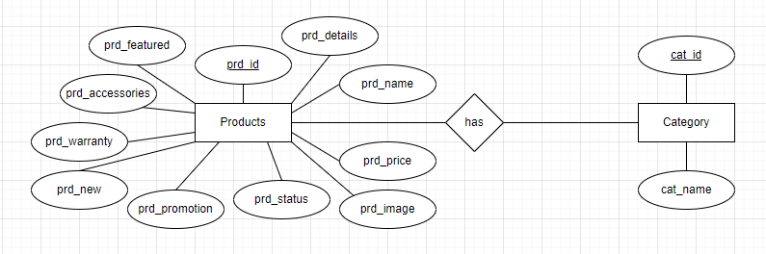

* 1. **Website Design.**
* Main Page:

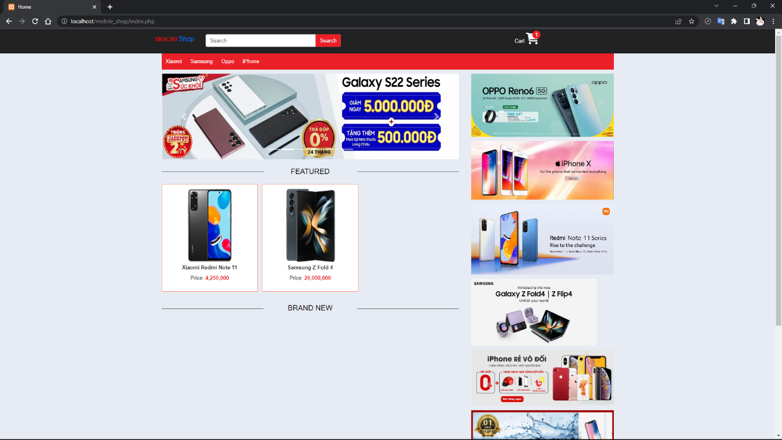

* Product Details Page:

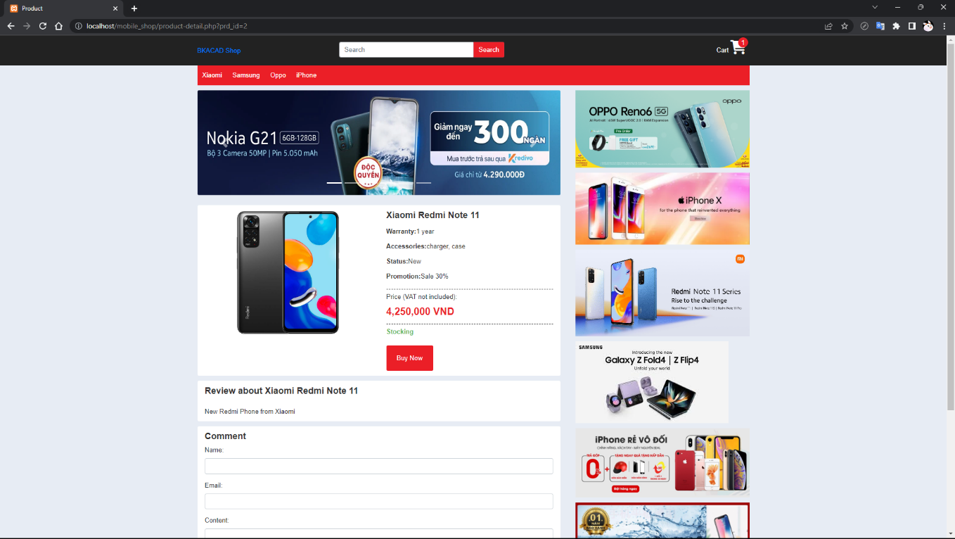

* Dashboard:

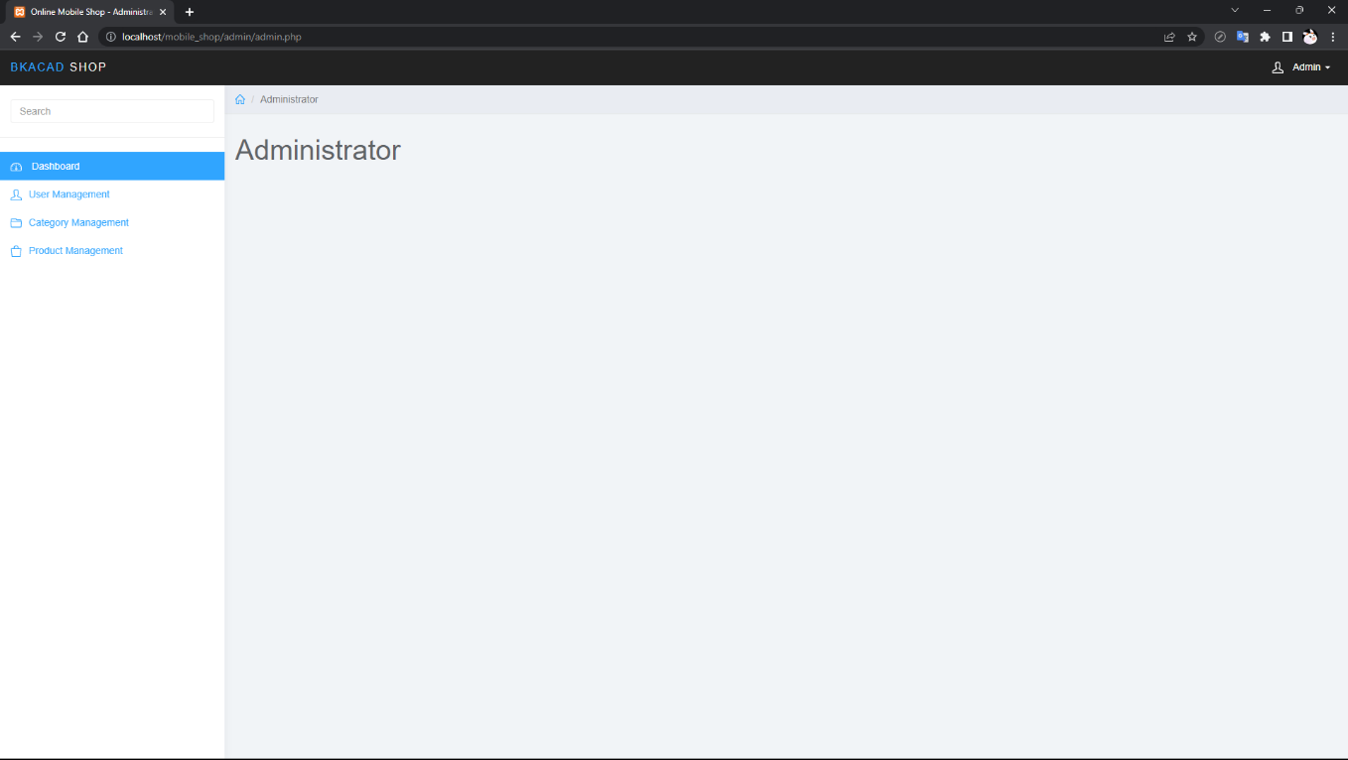

* User Management Page:

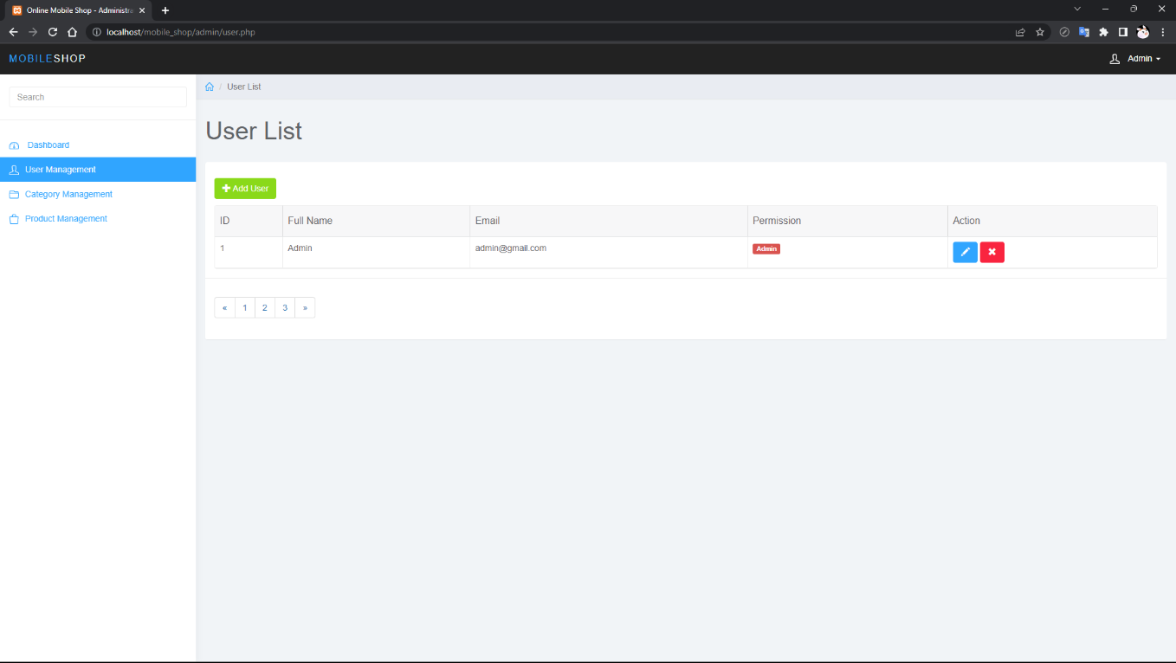

* Category Management Page:

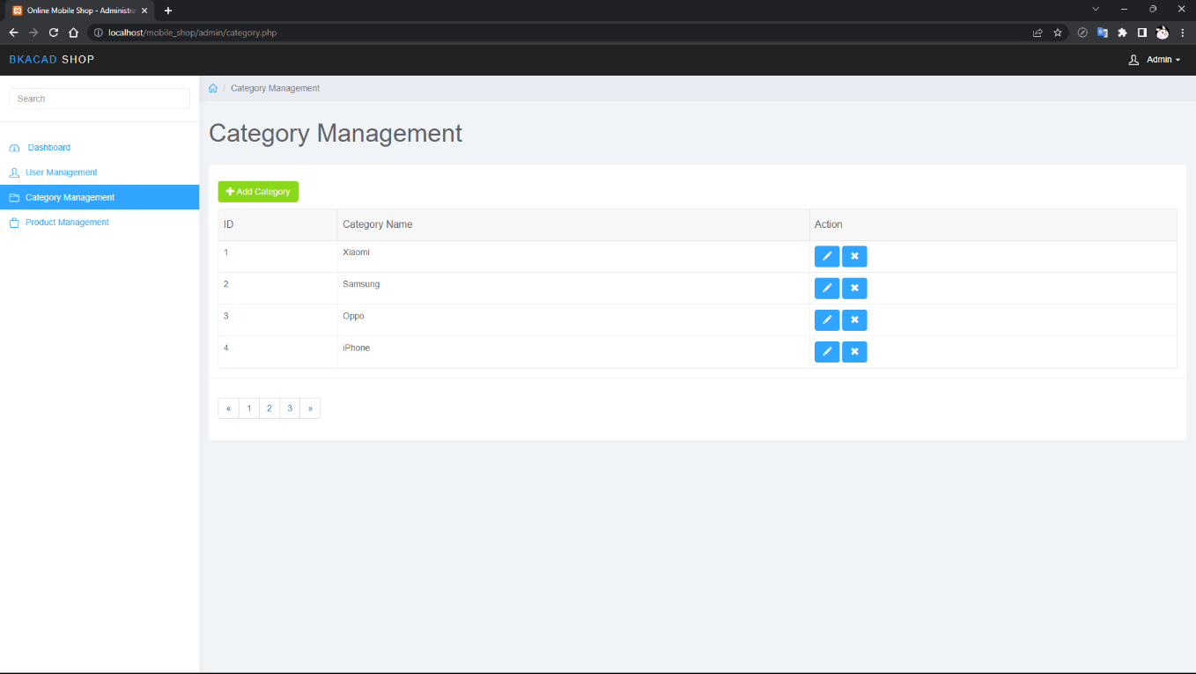

* Product Management Page:

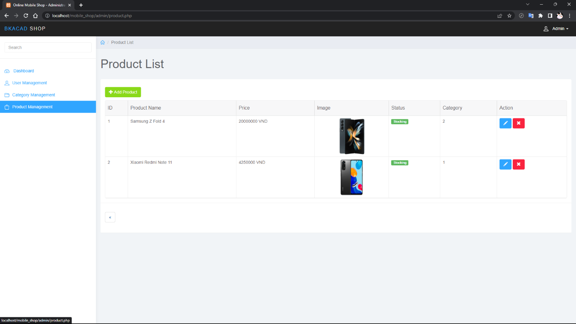

1. **Reference Links.**

https://www.webopedia.com/definitions/domain/

https://www.cloudflare.com/learning/dns/what-is-dns/

https://www.domaintools.com/support/what-is-a-domain-name-and-what-does-it-do/#:~:text=Domain%20names%20are%20organized%20via,%2Dlevel%20domains%20(ccTLDs).

https://blog.kdata.vn/tat-tan-tat-thong-tin-tu-a-z-ve-may-chu-web-server-ma-ban-phai-biet-248/

https://fptcloud.com/client-server/

https://bkaii.com.vn/tin-tuc/621-nhung-giao-thuc-mang-ban-nen-biet

https://techmaster.vn/posts/36830/cac-frameworks-frontend-web-tot-nhat-nam-2021

https://vieclam.thegioididong.com/tin-tuc/backend-la-gi-su-khac-nhau-giua-frontend-va-backend-252

https://aptech.fpt.edu.vn/bat-mi-backend-nen-hoc-gi-top-7-ngon-ngu-backend-thong-dung-nhat.html

https://softsupplier.com/nguyen-tac-trong-thiet-ke-ux-ui/

https://colorme.vn/blog/5-phan-mem-thiet-ke-ui-ux-duoc-yeu-thich-nhat

https://viblo.asia/p/cac-khai-niem-co-ban-ve-kiem-thu-phan-mem-63vKjR7dK2R

https://co-well.vn/nhat-ky-cong-nghe/10-cong-cu-kiem-thu-phan-mem-tot-nhat-cho-tester/

https://itviec.com/blog/qc-la-gi-qa-la-gi/

https://skillking.fpt.edu.vn/tin-tuc/seo/

https://www.usdigitalpartners.com/10-ways-to-improve-search-engine-ranking/